2.25: a) From Eq. (2.13), with 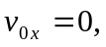
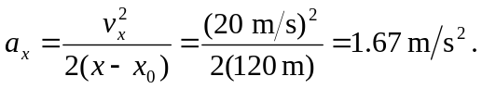

b) Using Eq. (2.14),
c) 